Aws offers different types of storage

* EBS [elastic block storage] volumes
* S3 [object level storage] object level storage
* EFS [elastic file system] shared files

Elastic block storage: - volumes [HDD][SSD] provides storage up to [1G-1Tb] in EBS we have 5 types of volumes

* General purpose SSD ex: - gp2, gp3s, used for development and test environment
* Provisioned lops SSD ex: - io2, io,
* Hard disk drives: - throughout optimized ex: - st1 used for data ware houses, log processing
* Cold HDD: - sc1
* Magnetic: -volume standard

For storing the data in instances, we use volumes there are dif types of volumes

while we creating a instance we get one default volume

how to create a volume

* Open the aws services in the service select ec2 and select the volumes and create the volume
* After creating the creating the volume attach the volume to the instance

Note: instance and the volume must be in the same region

* After attaching the volume to the instance open the terminal and see how many volumes are attached to the instance using command

Fdisk -l [ to list the disks]

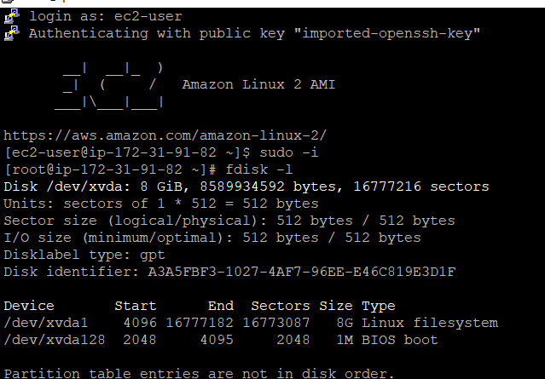

In Linux we cannot store the data directly

Linux windows

* Format the disk \* format the disk
* Create the partitions \* create the partions
* Create the file systems
* Mount

1blovcl=2mb

In one disk we create 4 primary partitions

* Format the disk and Create the partitions

The process of formatting the disk and creating the partitions are given below

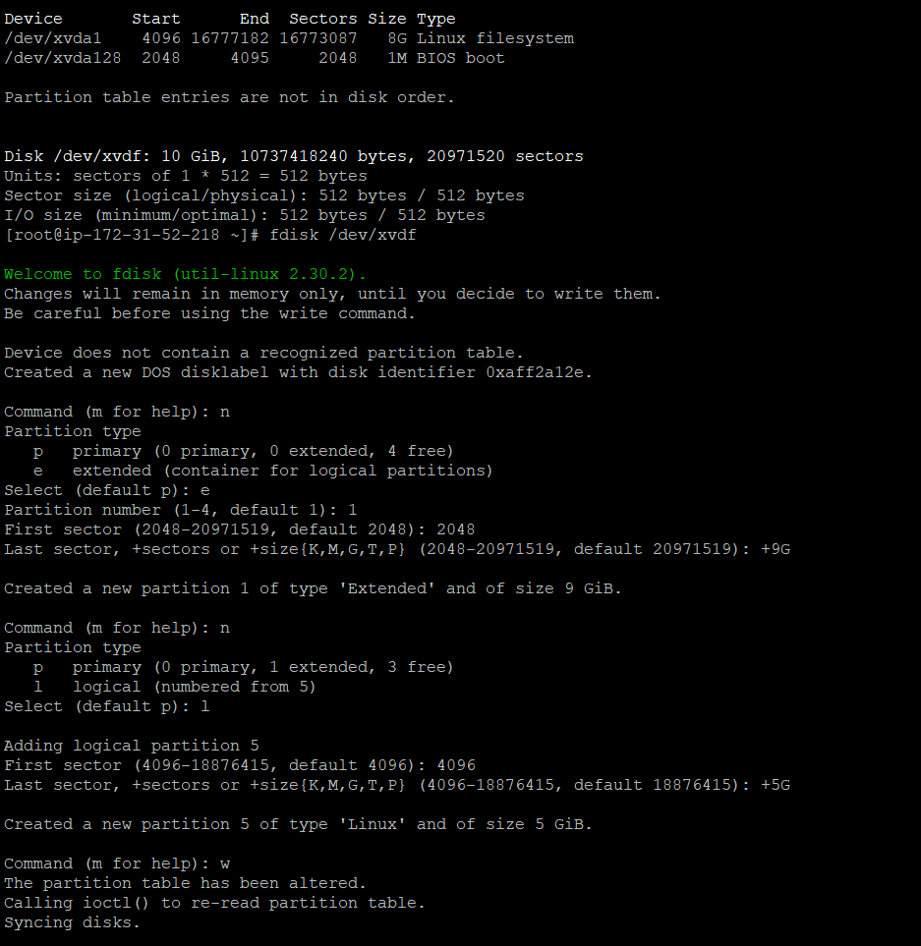Using

Fdisk /dev/xvdf formatted the disk

And {n} is the command to add the new partions

After applying the [n] command you will see two option they are

* primary: - support the OS
* Extended: - we don’t want OS
* Select the extended partitions using command [n]
* After selecting the extended you will see the

1}primary partion 2} logical partion

Select the logical partition using {l}command

{W} is the command to save and quit

Partprobe is the command to save this to kernel without restarting

* Create the file systems

mkdir /demofile

ls /demofile [ to list the files}

df -h [it shows which disk mounted to which folder]

after creating the files

* mount the disk with the files for example
* mount /dev/xvdf5 /demofile
* the xvdf5 disk mounted to demofile
* In below you can see the process step by how to create directory/folder and mounting
* after creating the directory/folder add some date in the folder
* touch /demofile/a{1..10}
* ls /demofile
* umount is the command to remove the disk with the folder/directory

umount /demofile

whenever you unmounted the folder from the disk the data will not be removed it will be stored in the disk

you can also mount another folder to that disk.

